MCU-based Automated Water Management System

Prepared for: **James Michael Cañete,** Instructor  
Prepared by: **Holchi Henche B. Alin, Janluke Gabriel D. Ceballos, Josh B. Ratificar, Mohan Nuelle T. Francis, Rodjean E. Gere** (2:30-5:30 MON)

13 May 2024

Executive Summary

# Rationale

The proposed development is the deployment of an automated water level monitoring and distribution control system. The system tracks water circulation issues and monitors water level in Barangay Garing, Consolacion, in Cebu to address the challenge in water management. The current labor-intensive method of water level monitoring and distribution control is not only dangerous to the individual involved, but also provides unequal allocation of water. Through the use of ultrasonic sensors the water level will be continually monitored and displayed on an easily accessible LCD panel. This avoids the need for an individual to check the water level of the tank and endanger themselves in climbing to inspect the water tank. It also allows for the provision of real-time data on the availability of water, thus assisting the barangay to take timely actions based on fluctuations in the water supply. The application of servo motors to automate the distribution of water based on preset thresholds optimizes the use of resources, ensuring that every “purok” (a.k.a district or zone) has equal access to water while saving water during the periods of scarcity. This approach not only improves the operations but also helps in the development of sustainability, resilience and improvement of life to the people of Barangay Garing.

# Problem

The basis of the water management system in Barangay Garing, Consolacion, Cebu, is on manual water level checking and ineffective water supply distribution - exposing the community to risks and unequal allocations of water. A modernized, automated system is needed to ensure safety, water efficiency and equitable access to water for the people of barangay Garing.

# Goals and Objectives

The project’s goal is to develop a MCU-based water management system capable of measuring the water level, displaying the measured water level, and activating servo motors that control the distribution of water. Furthermore, the following objectives are to be met:

- study of data on ultrasonic sensors.

- utilization of the instruments such as the ultrasonic sensor, and servo motors.

- design & development of the software that will perform the task of reading and displaying data from the sensor.

- design & development of the software that will control servo motors based on water level and time.

- design & development of the electronic systems for the sensor, LCD display, and servo motors.

# Scope & Limitation

The project scope involves only the construction of the water level monitoring system and servo controller, the design and implementation of the electronic circuitry required for the ultrasonic sensor, and the development of the software running on the MCU to perform the task required.

The proposed design has the following limitations:

* System performance is dependent on the tank environment and sensor calibration.
* The puroks served by the system are limited by the capacity of the microcontroller and servo motors.
* Data is not logged in a memory system.

# Conceptual Framework

The following is the conceptual framework of the proposed project.

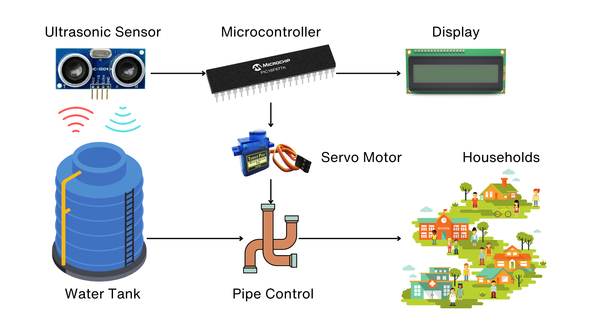

**Figure 1.0** - *Conceptual Framework*

They are interfaced to the microcontroller through their respective driver circuitry. The ultrasonic sensor, servo motor, and the liquid crystal display are directly interfaced to the MCU through the assigned GPIO ports. The ultrasonic sensor emits ultrasonic waves to gather depth data which is then used by the software. The data displayed are real-time and are constantly updated.

## System Block Diagram

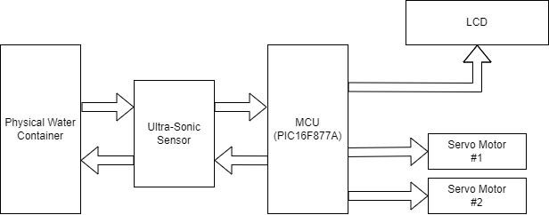

**Figure 2.0** - *System Block Diagram*

## Hardware Design

The system is controlled by the PIC16F877A microcontroller. The HC-SR04 ultrasonic sensor is mounted on a fixed stick above the water container. Using sensor data, the PIC calculates and displays the water level percentage (0% to 100%). It also controls two servo motors, each representing a pipe valve. When activated, the servo motors close the respective pipes, stopping the flow of water.

**Hardware Components:**

* 1x HC-SR04 UltraSonic Sensor
* 2x Servo Motors
* 1x LM044L LCD
* 1x 10k Potentiometer
* 2x 4MHz Crystal Oscillators
* 2x 20pF Capacitors
* 1x PIC16F877A Microcontroller
* 2x 2N2222 Transistor

## Software Design

The PIC16F877A microcontroller will facilitate communication with the ultrasonic sensor, interpreting its data to determine water depth. Utilizing the time taken for the ultrasonic signal to return, the system will gauge the water level through two key samples:

1. Total Time Taken with Empty Water Container: Establishes a baseline for time measurement when the container is devoid of water.
2. Total Time Taken with Half-Full Water Container: Provides a reference point for time measurement when the container is at a mid-point capacity.

Upon analysis of these samples, if the water level registers below or equal to 50%, a scheduler will be activated. The scheduler will systematically disable one servo motor at a time, allowing water flow through the enabled pipe. For demonstration purposes, the software will simulate scheduler activation at ten second intervals, although in practical applications, a scheduler would typically operate at longer intervals, such as every two hours. Conversely, if the water level surpasses 50%, the servo motors will deactivate, enabling simultaneous water flow through both pipes.

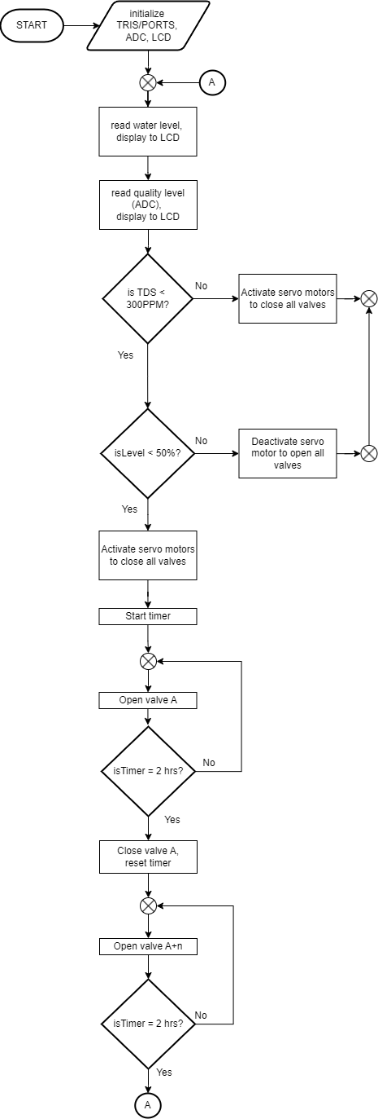

**Figure 3.0** - *System Design Flowchart*

# 

# Project Management

## Team Composition

**Josh Ratificar** (Team Leader/Hardware Lead) - Is responsible for the overall project development and progress. Employs the main hardware design and implementation methods.

**Mohan Nuelle Francis** (Member/Software Lead) - Assists the team leader and leads the software development which involves programming and interface design.

**Rodjean Gere** (Member/Hardware Design) - Responsible for the scheduler development.

**Holchi Henche Alin** (Member/Quality Assurance) - Responsible for integrating scheduler and sensor reading modules. Testing the integrated module.

**Janluke Gabriel Ceballos** (Member/ Documentation Lead) - Ensures documentation accuracy, completeness, and version control.

## Task Assignment

1. Development of the sensor device drivers (firmware) - Josh & Mohan
2. Design and prototyping of hardware components - Josh
3. Development of the task scheduler (firmware) - Rodjean
4. Programming and interface design for LCD display - Mohan
5. Integration of hardware and software components - Josh, Mohan, Rodjean
6. Integration testing and design validation - Holchi
7. Debugging and optimization - Holchi & Mohan
8. Coordination of project progress - Josh
9. Documentation and reporting - Janluke

# 

# Physical Experimental Setup

The experimental setup takes place within a household environment under carefully controlled conditions, ensuring the integrity of the data collected. Notably, precautions are taken to maintain a safe distance between electronic components and the water. It is worth mentioning that the container's dimensions measure 23 cm x 11 cm, as depicted in **Figure 4.0**.

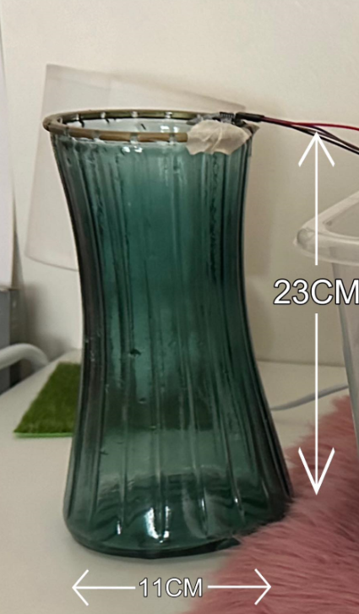

**Figure 4.0** - *Physical Water Medium*

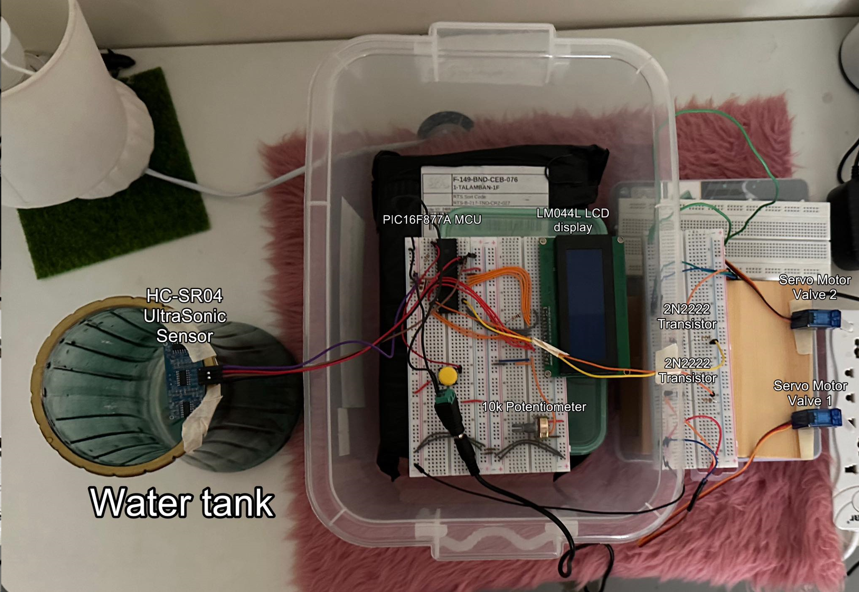

**Figure 5.0** - *Experimental Setup*

In the setup, the ultrasonic sensor is securely affixed to the top of the physical water medium using tape. Within the container, positioned alongside the water, are the LCD and the PIC16F877A microcontroller unit (MCU). Adjacent to the container, on the right-hand side, are the servo motor circuits, comprising transistor switches and a dedicated voltage source to power the servos when activated. This configuration ensures the reliable operation of the system while maintaining a clear separation between the electronic components and the water medium.

## Data Presentation & Analysis

The validation tests on the behavioral aspects of the system were conducted by designing test cases to determine when the servo motors should be activated based on the readings from the ultrasonic sensor.

# Ultrasonic Sensor Data

The ultrasonic sensor operates by emitting a pulse and measuring the time it takes for the echo to return after reflecting off the water surface. This time measurement is then utilized to calculate the distance, corresponding to the water level. The table below presents the sensor data for different water level states, with distance values expressed in centimeters. The PIC16F877A MCU system is configured with a prescaler of 1:1, utilizing Timer 1 for time measurements. To compute the distance **(L)** using the sensor, the factors taken into account are the time taken for the roundtrip **(T)** and the speed of sound **(C)**. The distance equation can be denoted as:

**L = (T/2) x C [EQ. *1*]**

| **Water Level** | **Distance (cm)** |
| --- | --- |
| Empty | 18.53 |
| Half capacity | 11.52 |
| Full capacity | 0 |

**Table 1.0 -** *Initial Ultrasonic Sensor Data for Different Water Levels*

During unit testing, inconsistencies were observed in sensor readings, characterized by spikes between measurements, rendering the system unstable. To address this issue, digital signal processing techniques, specifically the application of moving averages, were implemented. While this introduces a lag in sensor response, it ensures a more consistent and stable state.

| **STATE** | **DATA (cm)** |
| --- | --- |
| Empty | 20.03 |
| Half capacity | 10.02 |
| Full capacity | 0 |

**Table 2.0 -** *Ultrasonic Sensor Data for Different Water Levels with moving average*

It's noteworthy that while the physical water medium's height measures 23 cm, the internal curvature may affect the sensor readings, potentially explaining the deviation observed, such as the 20.03 cm reading for the empty state. Now that the readings are stabilized and closer to the true dimensions, the conversion to percentages for display on the LCD utilizes the formula:

**Percentage = 100 - (data_read x 5) [EQ. *2*]**

# Test Scenarios and Results

The following table outlines the results obtained in relation to the expected output. To ensure the robustness of the system, the actual output should align with the expected output for each scenario.

| **Scenarios #** | **Scenario** | **Output** | **Expected Output** |
| --- | --- | --- | --- |
| 1 | System initialization | Servo 1: Off  Servo 2: Off  LCD:   * Display water level | Servo 1: Off  Servo 2: Off  LCD:   * Display water level |
| 2 | Water Level: 0% | Servo 1: Off  Servo 2: Off  LCD:   * Display water level * Display Tank is empty | Servo 1: Off  Servo 2: Off  LCD:   * Display water level * Display Tank is empty |
| 3 | Scheduler: On  Servo 1: Enabled Water Flow  Servo 2: Disabled Water Flow  Water Level: Less than 50%  Timer: Reaches 0 | Servo 1: Off  Servo 2: On  LCD:   * Display water level * Timer Counts down from 9 to 0. | Servo 1: Off  Servo 2: On  LCD:   * Display water level * Timer Counts down from 9 to 0. |
| 4 | Scheduler: On  Servo 2: Enabled Water Flow  Servo 1: Disabled Water Flow  Water Level: Less than 50%  Timer: Reaches 0 | Servo 1: Enabled Water Flow  Servo 2: Disabled Water Flow  LCD:   * Display water level * Timer Counts down from 9 to 0. | Servo 1: Enabled Water Flow  Servo 2: Disabled Water Flow  LCD:   * Display water level * Timer Counts down from 9 to 0. |
| 5 | Scheduler: On  Servo 2: Enabled Water Flow  Servo 1: Disabled Water Flow  Water Level: Reaches 0%  Timer: Counts down to 0 | Both Servo 1 and Servo 2 disable water flow.  Timer stops.  LCD:   * Display water level * Display Tank is empty | Both Servo 1 and Servo 2 disable water flow.  Timer stops.  LCD:   * Display water level * Display Tank is empty |
| 6 | Scheduler: On  Servo 2: Enabled Water Flow  Servo 1: Disabled Water Flow  Water Level: Greater than or equal to 50% | Both Servo 1 and Servo 2 enable water flow.  Timer stops. | Both Servo 1 and Servo 2 enable water flow.  Timer stops. |
| 7 | Water Level: Greater than 50% | Servo 1: On  Servo 2: On  LCD:   * Display water level | Servo 1: On  Servo 2: On  LCD:   * Display water level |
| 8 | Water Level: Less than 50% | Servo 1: On  Servo 2: Off  LCD:   * Display water level * Turn on Scheduler | Servo 1: On  Servo 2: Off  LCD:   * Display water level * Turn on Scheduler |

**Table 2.0** - *Test Scenarios and Results*

# Conclusion and Recommendations

## Conclusion

The utilization of the PIC16F877A microcontroller effectively fulfills the required functionalities, particularly in automating water distribution by continuously monitoring the water levels of the tank. The system successfully controls the motors based on this data, demonstrating the viability of the conceptThe implementation of digital signal processing has significantly enhanced the system's stability, transforming it from an unpredictable and noisy state to one where noise is effectively mitigated through averaging. However, it's essential to acknowledge that the controlled experiment was conducted using a smaller-scale physical water medium measuring 23 cm x 11 cm, which differs significantly from an actual water tank in size and complexity. In an actual deployment scenario, the system would need to account for larger tanks and more robust components. For instance, while we employed servo motors in our experiment to simulate valve control, in a real-world setting, stronger mechanisms or actuators may be required to effectively manage the flow of water through larger pipelines or valves. Thus, further considerations and adaptations are necessary to ensure the seamless integration and performance of the system in practical applications.

## Recommendations

**1. Integration of Remote Monitoring:** IOT integration in which information monitored on the embedded system can be accessed on the web simply through wifi.

**2. Scalability Considerations:** Evaluate the scalability of the system to accommodate larger water tanks or multiple monitoring points. This may involve redesigning components or algorithms to handle increased data volume and processing requirements effectively. Such as introducing multiple ultrasonic sensors of a different kind. This would need amplifier circuits.

**3. Enhanced Sensor Redundancy:** Introduce redundancy in sensor systems to ensure continuous and reliable monitoring. By incorporating backup sensors or redundant measurement techniques, the system can maintain functionality even in the event of sensor failures or malfunctions.

**4. Water Quality Monitoring Integration:** Extend the functionality of the system to include monitoring of water quality parameters such as pH levels, turbidity, and temperature. Integrating water quality sensors would provide valuable insights into overall water health and enable early detection of potential contamination or issues.

## Project Timeline

| **Task** | May | | | | | |
| --- | --- | --- | --- | --- | --- | --- |
| 13 | 14 | 15 | 16 | 17 | 18 |
| Project Proposal Approval |  |  |  |  |  |  |
| Research on Ultrasonic Sensors |  |  |  |  |  |  |
| Design Circuit Diagram |  |  |  |  |  |  |
| Write the Code |  |  |  |  |  |  |
| Integration Testing |  |  |  |  |  |  |
| Debugging and Optimization |  |  |  |  |  |  |
| Submission of Project |  |  |  |  |  |  |

**Figure 4.0** - *Development of Timeline Chart*

## References

[1] Displaytech Ltd. “LCD Module Product Specification Product: 204A Series (20 Characters x 4 Lines)” , Displaytech 204A LCD Datasheet, April. 2009.   
Available: <https://www.seacomp.com/sites/default/files/datasheets/204A-Series-Displaytech-Spec.pdf>

[2] DFRobot “Gravity:AnalogTDSSensor/MeterForArduino SKU:SEN0244”, SEN0244 datasheet, (n.d). Available: <https://media.digikey.com/pdf/Data%20Sheets/DFRobot%20PDFs/SEN0244_Web.pdf>

[3] Handson Technology, “User Guide: Ultrasonic Sensor V2.0”, HC - SR04 datasheet, (n.d). Available:<https://www.handsontec.com/dataspecs/HC-SR04-Ultrasonic.pdf>

[3] Microchip “PIC16F87XA Data Sheet 28/40/44-Pin Enhanced Flash Microcontrollers”, PIC16F87XA datasheet, April. 2012.  
Available: <https://ww1.microchip.com/downloads/en/devicedoc/39582b.pdf>

[4] Tower Pro. “SG90 Datasheet”, SG90 datasheet, 2014.   
Available: <https://datasheetspdf.com/datasheet-pdf/791970/SG90.html>